

Fencing data exchange
XML input and output files for FIE fencing competitions
Version 3.3

Contributors:
- Ivy Wu (CHN) - Point
- Garcia Garcia, David (ESP) - Atos MSL
- Miguel Ojeda (ESP) - FC Esgrima
- Marina Shturbabina (FIE)
- Annick Fron (FRA) - Fencing Fox
- Nouredine Kaabi (FRA) - Kabcom
- Jean Francois Nicaud (FRA) - Engarde Team
- Sonja Lange (GER) - Ophardt Touch
- Saverio Tedeschi (ITA) – Fence
- Filip Skladanowski (POL) - MASK SPORT
- Tomasz Malanowski (POL) - MASK SPORT
- Thierry Cuenin (SUI) - Swiss Timing
- Nicolas Merico (SUI) - Swiss Timing
- Matthieu de Montarsolo (SUI) - Swiss Timing
- Daniel Berke (USA) - Fencing Time
Coordination: Julius Kralik (SVK) - EFC Sport Director

December 5th 2018

Introduction

Fencing competition softwares use XML files for data interchange of fencers, matches results, referees and pistes between fencing competition softwares and servers, and this document formalizes common practices in the domain in an update from the original document XML_Specifications_FIE.pdf written by J.F. Nicaud on 31/12/03 and updated version from 19.07.12.
As the original document, it handles both input and output files. It tries to preserve upward compatibility to existing practices.
This document is accompanied with samples together with an XML schema reference file that can be used by XML checking softwares to automatically check the conformity of the files to the standard (XML Spy, Oxygen XML, etc.).
This document adds new features to follow up new competitions styles like mixed Italian relay matches. It defines mandatory and optional attributes of each XML element.
The context and objectives are the following:
- XML format for fencing at any level, for the FIE
- XML files for starting competitions
- XML files for competition results for
  - Updating rankings
  - Displaying state/results of the competition at any stage (but not live display)
- For research of medical commission (that is why we need several signs for indicating that fencer did not finish competition)
- Harmonize with ORIS files

Contents
1 Introduction 2
3 Vocabulary 5
3.1 Competition types 5
3.2 Competitors 6
4 Overview 6
5 Xml notations 10
5.1 References inside the document 10
5.2 Encoding 10
5.3 Elements and attributes 11
6 XML schema defining the syntax for both input and ouput XML files 11
6.1 Document root elements 11
6.1.1 CompetitionIndividuelle 11
6.1.2 CompetitionParEquipes 15
6.1.3 BaseCompetitionIndividuelle 16
6.1.4 BaseCompetitionParEquipes 17
6.1.5 Important difference of structure between CompetitionParEquipes et BaseCompetitionParEquipes 17
6.2 Xml elements 19
6.2.1 Tireurs 19
6.2.2 Status 22
6.2.3 Ranking 24
6.2.4 Equipes 25
6.2.5 Match 27
6.2.6 Exceptional cases (DNS, DNF, EXC, MED) 30
6.2.7 Assaut 31
6.2.8 Italian relay matches with several weapons 33
6.2.9 Phases 33
6.2.10 TourDePoules 33
6.2.11 Poule 35
6.2.12 PhaseDeTableaux 38
6.2.13 SuiteDeTableaux 39
6.2.14 Tableau 41
6.2.15 Matches de barrage 42
6.2.16 Senior competitions 42
6.2.17 Arbitres 43
6.2.18 Officials 44
6.2.19 Pistes 45
6.3 Enumerated values 45
6.3.1 Status of Tireur 45
6.3.2 Weapons 45
6.3.3 Competition categories 46
6.3.4 Gender 46
6.3.5 Competition domain 46
6.3.6 Team competition type 47
6.3.7 Status of a poule or a match or an assaut 47
6.3.8 Role of an official 47
6.3.9 Role of a referee 47
6.3.10 Handisport competition class (Classe) 47

Vocabulary

A Tournament groups several Competitions, possibly on several days.
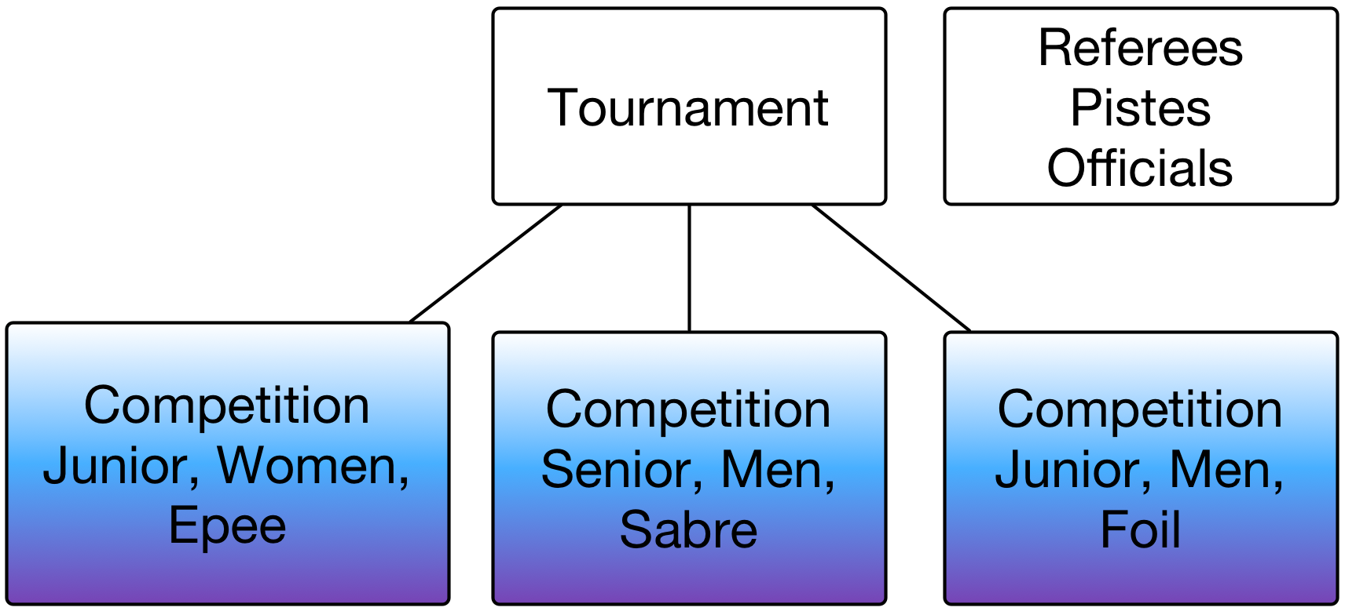
A competition is defined by its sex (feminine, masculine, mixed), its category (senior, junior, U20…), and its weapon (epee, foil, sabre). Recently new kinds of competition mix several weapons in the same team matches.

Competition types
There are 3 types of competitions: individual, team and italian relay. Italian relay is a new feature with respect to existing practices.
In a team match, all fencers in a team will fight against all fencers in the other team, leading to 9 rounds (assauts).
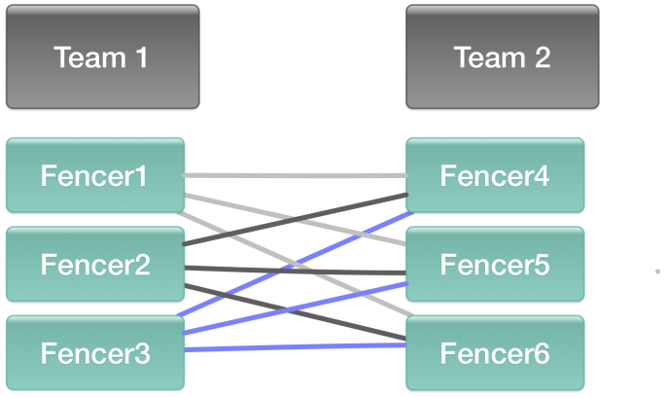
In an Italian relay match, all team fencers will encounter only one opponent. The team size in an Italian relay may vary, 2,3 and 6 are the most used. The number of matches in an Italian relay (Relais à l’italienne) is the number of fencers of each team.
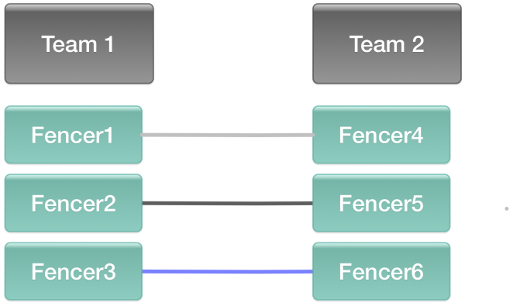
In individual competition matches, there are usually 3 rounds for tables, and 1 round for poules, all rounds with the same fencers. For simplicity, individual table results are summarized as one round, but for connected machines, the round number must be incremented.
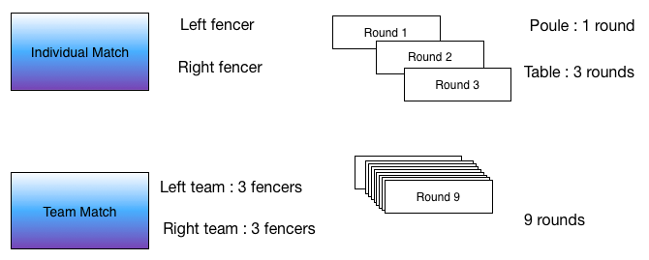
In team matches, there are usually 9 rounds (3 x 3) so that every team member meets every member of the other team.
In Italian relay matches there are as many rounds as members of the team.

Competitors
A competitor is a generic term used either for participants in an individual competition or for teams in team or Italian relay competitions.
A team is composed of individual fencers in a defined order. In an Italian relay, fencers may appear several times in the team if they fight more than once (example from formula In Championnats de la Mediterranée in Marseille, sequence of men epee, men foil, men sabre, men sabre, men foil, men epee).

Overview
The xml documents are organized in a hierarchical manner from a root.
The roots are the following:
- BaseCompetitionIndividuelle for preparation of individual competitions
- BaseCompetitionEnEquipes for preparation of team competitions
- CompetitionIndividuelle for results of individual competitions
- CompetitionParEquipes for results of team competitions
The competition usually defines fencers or teams, referees and results if it is the case. The results are decomposed in stages of the competition (Phases) in chronological order.
The competition may be composed of any number of stages in a sequence. Stages are of 2 types: Phases de tableaux and Tour de poules.
A Phase de tableaux includes several Suite de tableaux. A Suite de Tableaux is a sequence of Tableaux played in a sequence.
Each Suite de Tableaux includes several Tableaux, and each Tableau several matches.
In the same way, a Tour De Poules includes several Poules, each Poule with several matches.
Each Match includes 2 Tireurs (individual participants) or includes several Assauts (rounds), each one with 2 Tireurs, depending if the competition is individual or team or Italian relay.
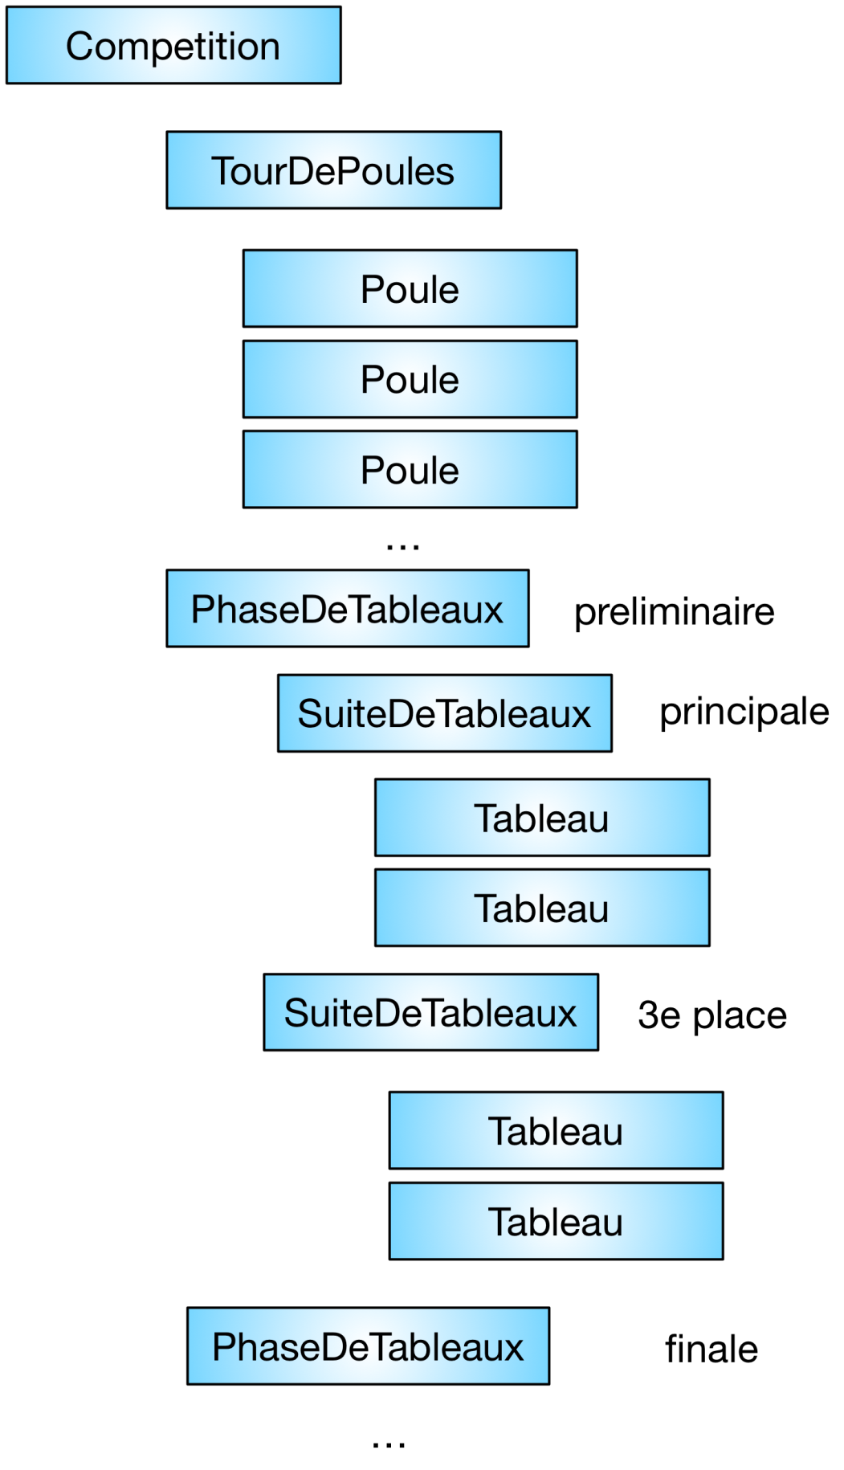
Table 1: Competition decomposition
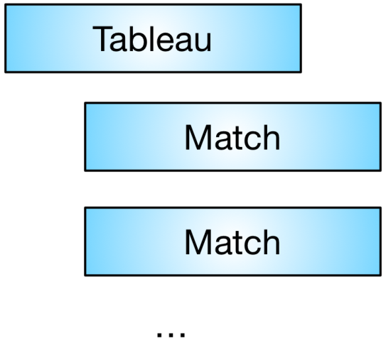
Table 2: Tableau decomposition
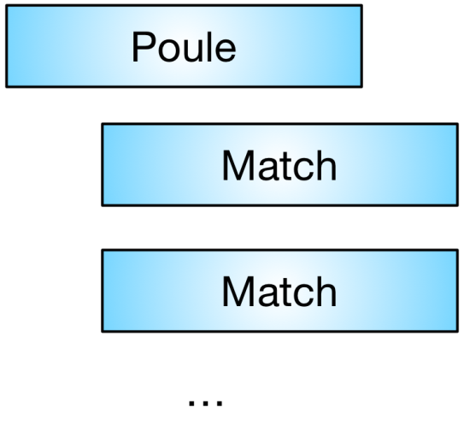
Table 3: Poule decomposition
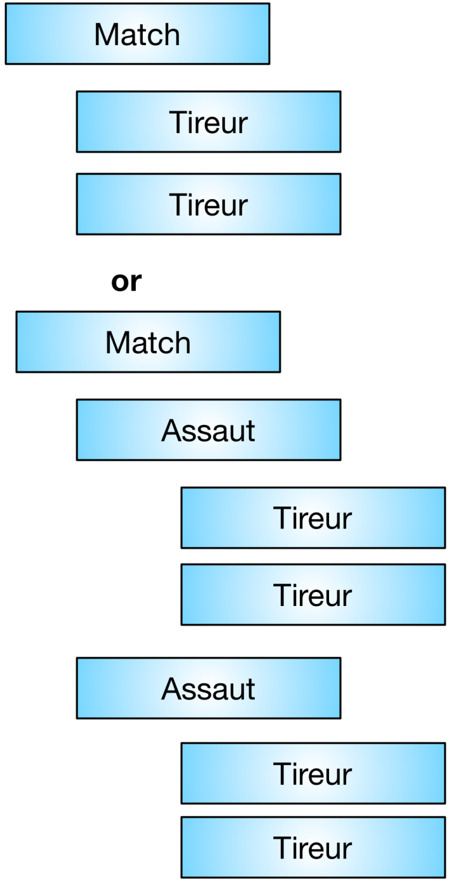
Table 4: 2 alternative match decompositions

Xml notations

References inside the document
XML allows to define references inside a document.
Typically, the fencers (Tireurs) will be defined at the top of the competition, and each match will hold a reference to a fencer using the REF attribute pointing to the Tireur ID, e.g.
Tireur ID = “13” Nom=”Dupont”
Tireur REF = “13” will reference Tireur Dupont

Encoding
The encoding for the XML files will be preferably UTF-8. For upward compatibility ISO-8859-1 (western Europe) will be accepted. In an XML file the encoding is specified at the top of the document.

Example:
<CompetitionIndividuelle Annee="2016/2017" Arme="E" Categorie="S" Championnat="FIE" Date="10.02.2017" Domaine="I" Federation="ITA" ID="92" Organisateur="" Sexe="F" TitreCourt="2017-9" TitreLong="Coupe du Monde">

Elements and attributes
The XML schema will define a structure of elements composed of attributes and other elements.
The notation use="required" will indicate that the attribute is mandatory.
The notation minOccurs="0" maxOccurs="unbounded" will indicate that the collection may have zero or n elements.
The notation xsChoice indicates that the expected element might be of different types, e.g.:
<xs:choice minOccurs="0">
<xs:element minOccurs="0" maxOccurs="unbounded" ref="Equipe"/>
<xs:element minOccurs="0" maxOccurs="unbounded" ref="Tireur"/>
</xs:choice>
Indicates that the expected element may be either an Equipe or a Tireur.

XML schema defining the syntax for both input and ouput XML files

Document root elements
The reference file holds for both input and output XML files.
In input files, the root of the document is either a BaseCompetitionIndividuelle or a BaseCompetitionParEquipes.
For output files, the root of the document is either CompetitionIndividuelle or CompetitionParEquipes.
Mixed Italian relays will be using the same structure as team competitions with a different type.

CompetitionIndividuelle
CompetitionIndividuelle is the root element of individual competition results.
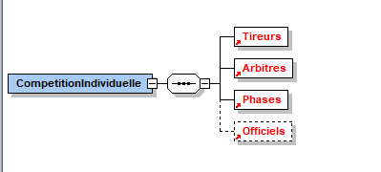
It holds a list of Tireurs for fencers who fenced in the competition, a list of Arbitres empty or not for referees involved in the competition, a list of Phases for competition results.
Officiels is an optional element to document DT, referee commission, etc.

Attributes of CompetitionIndividuelle
Attribute name | Type | Mandatory | Comment
Annee | Xs:string | x | Year or season where the competition took place. In the case of FIE competition, this will hold 2 consecutive years separated by the « / » character, e.g. 2002/2003.
Arme | Xs:string | x | Weapon code of the competition. Allowed values are (F = Foil,  E = Epée and S = Sabre, M = Mixed)
Categorie | Xs:string | x | Competition category. Allowed values are: S = Senior, J = Junior, C = Cadet, V = Veteran, …)
Championnat | Xs:string |  | The Championnat attribute identifies the organization which holds the calendar and the ranking (FIE or IOC nation code for each country)
Classe | Xs:string |  | Classification for handisport competitions (A, B, C, Open)
Date | Xs:string | x | Start day of the competition with the following format: DD.MM.YYYY. Required for the Scoreboards (it is also possible to use the new “Date” attribute of the element “Match” because a lot of competitions last more than one day).
DateDebut | Xs:string |  | For competitions spanning several days in format: DD.MM.YYYY
DateFin | Xs:string |  | For competitions spanning several days in format: DD.MM.YYYY
DateFichierXML | Xs:string |  | Date of creation of the XML file (from FIE document 2012) in the following format: DD.MM.YYYY HH:MM
Domaine | Xs:string |  | Competition domain code. The allowed values are:  I = International,  N = National,  R = Regional,  L = League,  C = clubs,  Z = zone
Federation | Xs:string |  | Code of the federation in charge of the competition. The allowed values are the nation codes defined by IOC (optional)
ID | Xs:string | x | The ID attribute is a unique identifier in the organizer’s calendar. In the FIE case, this ID is provided to the organizers in the input preparatory file.
IDTournoi | Xs:string |  | Tournament ID (similar to competition ID, but applied to a group of related competitions)
Lieu | Xs:string |  | Location of the competition
LiveURL | Xs:string |  | URL for live results
Organisateur | Xs:string |  | Optional – Name of the organizer
Sexe | Xs:string | x | Gender of the competition. Allowed vales are: M (masculine), F, (feminine), X (mixed). Required for the Scoreboards and the Scouting.
TitreCourt | Xs:string |  | Short text representing the competition name (optional)
TitreCourtTournoi | Xs:string |  | Tournament short description
TitreLong | Xs:string |  | Long name representing the competition name (optional)
TitreLongTournoi | Xs:string |  | Tournament long description
Titre1 | Xs:string |  | To split titles in several lines
Titre2 | Xs:string |  | To split titles in several lines
Titre3 | Xs:string |  | To split titles in several lines
Titre4 | Xs:string |  | To split titles in several lines
URLorganisateur | Xs:string |  | Link on the organizer web site
Version | Xs:string |  | Version of the XML grammar (3.3 for this document version)
VideoURL | Xs:string |  | Video URL
ZoneHoraire | Xs:string |  | Time zone of the competition (GMT,GMT+1, GMT-1…)

For fencers’ attributes:
- The RangInitial attribute holds the fencer ranking before the competition in the ranking attached to the calendar (official FIE ranking, national ranking…). In case the fencer has no previous ranking, the attribute is omitted.
- Classement is the final ranking of the fencer in the competition. In case the fencer has no ranking, the attribute is omitted (see FIE document 2012).
- The Points attributes holds the fencer’s number of points before the competition
- The Statut attribute (Status of the fencer) is present only in case of exceptional exits (DNS, DNF, EXC, MED)
- In case of FIE competitions, the fencer’s attributes Ligue (league) and Club (club) are absent.
- In order to ensure the transition between versions, the root competition must provide a Version attribute with the value of 3.3, in order for software to manage different document structures.
<CompetitionIndividuelle… Version=”3.3”…./>

CompetitionParEquipes
This type of document allows for team competition results.
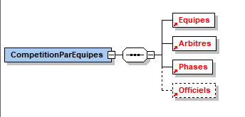
The attributes are the same as CompetitionIndividuelle with 2 new attributes: TypeCompetition and TailleEquipe.

TailleEquipe | Xs:string | Mandatory for Italian relays | Team size. Only needed for italian relays.
TypeCompetition | Xs:string | x | Type of team competition among:  - S=Standard  - I=Italian  - V=V (Veterans WCH)  Will be required for the Scoreboards.

The type accounts for different type team competitions:
- S is a standard team competition
- I is an Italian Relay competition as explained above
- V is a veteran competition. In this type of competition, the score is by number of victories instead of cumulative scoring
TailleEquipe is the team size and is mandatory for Italian relays, since the team size may vary, for instance 2, 3 or 6. The team size is used to generate the proper number of rounds and to check if teams are complete.
The Tireurs section is replaced by a Equipes section. Each Equipe holds a list of Tireurs.
Warning: we could also list the fencers composing teams in a Tireurs section, but this option has not been chosen.

BaseCompetitionIndividuelle
BaseCompetitionIndividuelle is used for input individual competition preparatory files.
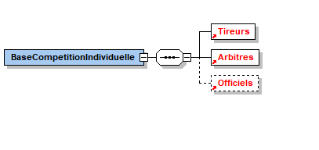
The attributes are the same as CompetitionIndividuelle with the following remarks:
- The competition ID is provided to the organizers by the FIE using the ID attribute. This ID must be returned as well as the year (Annee) in the competition result file
For fencers’ attributes:
- The Classement attribute holds the fencer ranking before the competition in the ranking attached to the calendar (official FIE ranking, national ranking…). In case the fencer has no previous ranking, the attribute is omitted.
- The Points attributes holds the fencer’s number of points before the competition
- The Statut attribute (Status of the fencer) is absent
- In case of FIE competitions, the fencer’s attributes Ligue (league) and Club (club) are absent.
- The Phases section is absented from the file.

Important note: For upward compatibility issues, Classement has not the same meaning in input files and in output files.
Example of attributes:
<?xml version="1.0" encoding="UTF8"?>
<BaseCompetitionIndividuelle xmlns:xsd="http://www.w3.org/2001/XMLSchema" xmlns:xsi="http://www.w3.org/2001/XMLSchema-instance" Championnat="FIE" ID="92" Arme="E" Sexe="F" Domaine="I" Federation="ITA" Categorie="S" TitreLong="Coupe du Monde" Annee="2016/2017" Date="10.02.2017" DateFichierXML="08.02.2017 15:40">

BaseCompetitionParEquipes

This file is similar to the individual competition preparatory file with the following exceptions:
- The root name of the document is BaseCompetitionParEquipes
- In case of FIE competitions, the attributes Ligue and Club (league and club) are absent for fencers and teams
- The Ligue (league) attribute of referees is absent for FIE competitions
- The file includes a section composed of teams (Equipes). Each Equipe element is similar to team competitions result files with the following exception:
- The Classement attribute holds the ranking of the team before the competition in the organizer ‘s calendar; it is omitted if there is no previous ranking
- The Points attribute holds the points of the team before the competition
- The Statut attribute (team status) is absent
- TypeCompetition is required for CompetitionParEquipes, and TailleEquipe is required for Italian relays
- Officiels is a new optional element to hold DT or referee information

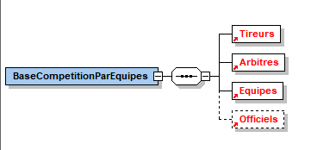

Important difference of structure between CompetitionParEquipes et BaseCompetitionParEquipes

In BaseCompetitionParEquipes, there is a list of fencers, Tireurs, and each fencer has a pointer to the ID of his team.
Example
<Tireur ID="39" Nom="QUEROLI" Prenom="Caroline" DateNaissance="05.06.1998" Sexe="F" Lateralite="D" Nation="FRA" Licence="05061998000" dossard="7539" Equipe="FRANCE" Classement="4" Statut="N" Points="124.00" />

Teams don’t hold any fencer.
<Equipe ID="FRANCE" Nation="FRA" Classement="2" Statut="N" Points="304.00" />

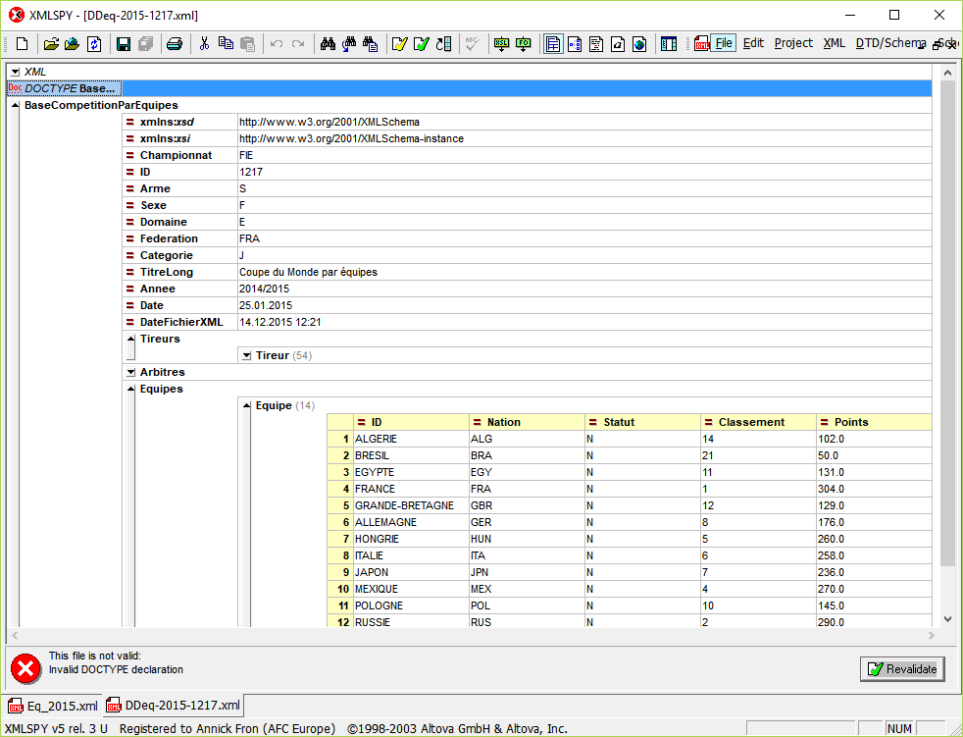

In CompetitionParEquipes, there is no list of fencers, and fencers are held within teams.
<Equipe ID="4" Nation="FRA" Classement="1" >
<Tireur ID="5" Nom="BALZER" Prenom="Sara" … Nation="FRA"/>
<Tireur ID="9" Nom="BRUNET" Prenom="Manon" … Nation="FRA"/>
<Tireur ID="43" Nom="QUEROLI" Prenom="Caroline" … Nation="FRA"/>
<Tireur ID="45" Nom="RIFKISS" Prenom="Margaux" … Nation="FRA"/>
</Equipe>
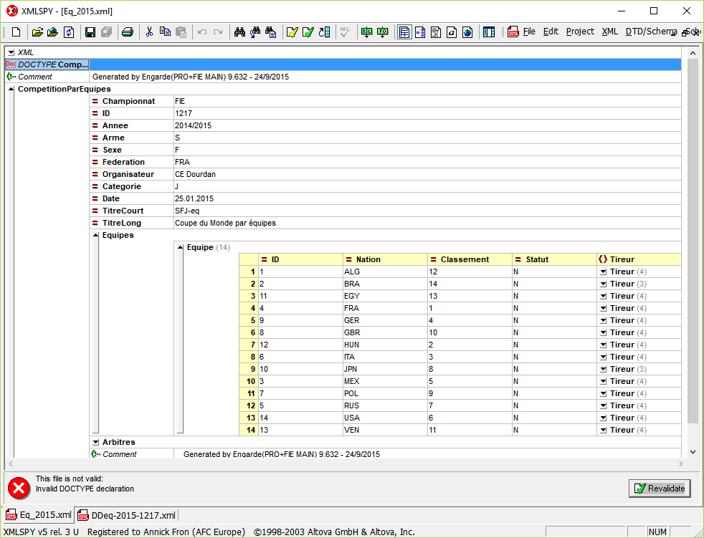

Xml elements

Tireurs
The Tireurs element is an unbounded collection of Tireur, which may be empty.
A Tireur element represents either an individual participant at the top of the competition or a competitor inside a match.
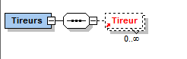
If a Tireur is not ranked, his/her ranking is omitted. If the Tireur status is normal, it is omitted.

Attributes of a Tireur
Name | Type | Mandatory | Comment
Arme | Xs:string |  | Optional. Used for mixed weapon competitions. Any value among E, F, S.
CartonJaune | Xs:integer |  | Optional. Number of yellow cards received by the fencer in the match (0,1)
CartonRouge | Xs:integer |  | Optional. Number of red cards received by the fencer in the match (0,1,...n)
Classement | Xs:integer |  | In the input files: official FIE or national ranking before the competition. In the output files: final ranking in the competition. Must be omitted if the fencer has no ranking. (FIE document 2012)
ClassementFusionne | Xs:integer |  | In the output files, merged ranking in the case of 2 poules, at the end of the second poule
Club | Xs:string |  | Fencer’s club (optional).
Cote | Xs:string |  | Side of the fencer within a match. D for right (Droit), G for left (Gauche). This is used for video. Usually the first fencer in a match goes to the right, unless the referee swaps fencers.
DateNaissance | Xs:string |  | Birth date of the fencer in the format dd.mm.yyyy or yyyy
DemandeVideoRejetee | Xs:integer |  | Optional. Number of unsuccessful video requests (0,1,2)
Dossard | Xs:integer |  | The mask number of the fencer
Equipe | Xs:string |  | Name of the team it belongs to if it is the case
ID | Xs:string | x | Unique identifier in the competition. In FIE files this comes from the database identifier. Mandatory inside lists of fencers. Inside matches or poules, only REF is used.
IDTournoi | Xs:string |  | Fencer personal ID in the tournament accreditation system
Lateralite | Xs:string | x | D for right handed, G for left-handed; only in input files. Required for the Scoreboards and the Scouting.
Licence | Xs:string |  | Fencer’s license number in the competition calendar. This number is provided to the organizers in the input files.
LicenceNat | Xs:string |  | The national license identifier of the fencer
Ligue | Xs:string |  | Fencer’s league (optional)
Nation | Xs:string | x | Fencer’s nation code according to CIO codes. This is mandatory for FIE competitions. Required for the Scoreboards and the Scouting.
NbMatches | Xs:integer |  | Number of matches fought inside the poule. Used in the context of a poule
NbVictoires | Xs:integer |  | Number of victories inside the poule. Used in the context of a poule
NoDansLaPoule | Xs:integer |  | Initial seeding inside the poule. Can be used to infer lines and columns inside a poule grid. Used in the context of a poule
Nom | Xs:string | x | Name of the fencer. Required for the Scoreboards and the Scouting.
Prenom | Xs:string | x | First name of the fencer. Required for the Scoreboards and the Scouting.
PhotoURL | Xs:string |  | Photo URL of the fencer
Points | Xs:string |  | Points contains the number of points of the fencer in relation to his/her ranking. The decimal separator is a dot (.)
REF | Xs:string |  | Reference to the ID of a Tireur inside a Match, a Poule, a TourDePoules or any other entity
RangFinal | Xs:integer |  | Used inside stages. Omitted if no final ranking in a stage. Mandatory when the information is known
RangInitial | Xs:integer |  | Used inside stages and in the competition.  Can be used to store FIE ranking before the competition in output files at the competition fencers list level.
RangPoule | Xs:integer |  | Used inside Poules: ranking inside the poule. Required for the Scoreboards, should be mandatory when the information is known. Omitted if the poule fencer has no ranking
Score | Xs:integer |  | Used inside a Match. Omitted if the match has not begun or has not been fought. Required for the Scoreboards, should be mandatory when the information is known.
Sexe | Xs:string | x | Gender code (M = Masculine et F = Feminine).
Statut | Xs:string |  | Status of the fencer. Various meanings according to the context. Required for the Scoreboards, should be mandatory when the information is known.
TD | Xs:integer |  | Used inside a poule: number of given hits. Required for the Scoreboards, should be mandatory when the information is known.
TR | Xs:integer |  | Used inside a poule: number of received hits. Required for the Scoreboards, should be mandatory when the information is known.
Important note: License takes a “c” in French as in “Licence”.

Status
The status of a fencer has different meaning according to the context (competition, stage, poule, match).
In the following competitor will mean fencer or team.
All competitors listed in the XML input file, even excluded, will be listed in the result XML file, unless there is a confirmation stage and they are marked as not present . They might or might not have a ranking and might or might not have an exceptional status.
They may have both a ranking and an exceptional status.
The exceptional values are:
- DNS (Did not start): Did Not Start / withdraw of fencer before start of competition
The competitor did not start the competition, or exempted fencer did not show up for final tableau in senior competitions, or the competitor did not show up for medical reason before the competition; no ranking for the competitor
Note: DNS has also connotation with FIE imposed financial sanction. DNS in xml-results files would automatically initiate procedure of requesting payment defined in FIE Rules except provided medical certificate or prove of "force majeure" (see relevant FIE rules)

- MED (Medical): withdraw of fencer during competition for medical reason - injury
The competitor has a final ranking only if it finishes either a complete poule or a complete tableau match.
- DNF (Did not finish): withdraw of fencer during competition for technical reason other than medical
The competitor has a final ranking only if it finishes either a complete poule or a complete tableau match.
- Exclusion (EXC): imposed withdraw of fencer for discipline reasons (exclusion) described in FIE Rules, followed by suspension for defined period (sanction) (disciplinary black card)
The competitor has no ranking after competition.

The following rules apply :
- All competitors inscribed in the initial XML file will be included in the results XML unless there is a confirmation stage and they are not present. Each Tireur/Equipe in the results XML may include the Statut of the competitor (DNS, DNF, MED, EXC) only in exceptional cases. Note : it is very important to remove fencers not present in the confirmation stage to be able to compute exempted fencers from the XML.
- Competitors that complete the event normally will appear in the XML results without a Statut and will include their final ranking in the Classement field.
- If competitors are not present to fence in their first bout of the competition, then their Statut is DNS and they do not have a Classement in the final results.
- If a competitor is excluded (black card) in any phase of the competition, the Statut is EXC and he/she/it does not have a Classement in the final results.
- If competitors are present but do not finish at least one poule, or one DE match because of a medical reason, the Statut is MED, because of non-medical reason the Statut is DNF, and they do not have a Classement in the final results.
- If competitors complete at least one poule or one DE match and later fails to appear or must withdraw for medical reasons, their Statut is DNF or MED as appropriate, and they have a Classement in the final results
Comment : these general rules rules apply in particular for teams who require generally at least one DE match, for exempted fencers, who require at least on Final tableau match, for competitions with 2 rounds of poules, where a fencer with one poule only will get a ranking.

Important note: The status of a fencer in the overall competition fencers list is the status of the last stage in which the fencer is participating. It is omitted if it is normal. This is a difference with the present situation, where he/she has a status of “N”.

Outside of these statuses, the status may also denote operational status according to the context:
Inside a match:
- V for victory
- D for defeat
Inside a stage:
- Exempted (X): a stage will only list fencers exempted at the end of it, it will not list fencers exempted at the beginning of the stage.
- Qualified (Q): fencers qualified for the next stage
- Non-Qualified (N): fencers not qualified for the next stage
In case the status is not known or is normal, the attribute is omitted (no default value). For instance, at the end of the final stage, the fencer’s stage status will be skipped (no qualification is needed because there is no following stage).

Ranking
In the result files, inside a competition, the fencers list (Tireurs element of the root document) will provide for each fencer of the input file, or for any present fencer if there is a confirmation stage:
- Classement: final ranking of the fencer at the end of the competition
- RangInitial (optional): ranking of the fencer before the competition in the organizer’s calendar (Classement coming from input files)
- Optionnally a Statut, in case of exceptional case
Inside a stage, the fencers list will provide for each fencer:
- RangInitial: seeding of the fencer inside the stage (for instance in a tableau preceded by a poule, the poule ranking)
- RangFinal: final ranking of the fencer inside the stage, for instance tour de poules ranking or phase de tableau ranking
- Optionnally a Statut, in case of exceptional case, or to indicate qualification or exemption if there is a following stage

In case of ties, the ranking will not have any special notation. This extension (for instance 3T or =3) may be reflected in the display but not in the XML result files.

In case the fencer has no final ranking in the competition, the Classement attribute will be omitted like below (see FIE document 2012):
<Tireur RangInitial="2" ID="21" Nation="FRA" Nom="REMBI" Prenom="Lauren" …></Tireur>
The Statut will be omitted unless there is an exceptional status (DNS, DNF, EXC, MED).

Usual case:
<Tireur Nom=”Somebody” Classement=”45” …./>
Both status and ranking:
<Tireur Nom=”Somebody” Classement=”45” Statut=”MED” …/>
Only exceptional status:
<Tireur Nom=”Somebody” Statut=”MED”>
<Tireur Nom=”Somebody” Statut=”EXC”>
Like in Oris, the fencers with the same status and without ranking will be listed in alphabetical order, and the status will be listed in the following order: DNS, MED, DNF, EXC

Important note: at present, there is a different meaning for the Classement attribute which is used in input files for FIE ranking before the competition, and in output files for final ranking after the competition. For upward compatibility we keep these 2 meanings.

Example of a participant inside the fencers’ list of an input file (no Statut)
<Tireur Classement="2" ID="21" Licence="09031992000" Nation="FRA" Nom="REMBI" Prenom="Lauren" Sexe="F"></Tireur>
Example of a participant inside the fencers’ list of an output file (no Statut if normal, both Classement and RangInitial; RangInitial has the value of the Classement in the input file)
<Tireur RangInitial="2" Classement="3" ID="21" Licence="09031992000" Nation="FRA" Nom="REMBI" Prenom="Lauren" Sexe="F"></Tireur>
Example of a participant inside the fencers’ list of an output file (Statut of MED, both Classement and RangInitial)
<Tireur RangInitial="2" Classement="3" ID="21" Licence="09031992000" Nation="FRA" Nom="REMBI" Prenom="Lauren" Sexe="F" Statut=”MED”></Tireur>
Remark: In this case, the medical injury must have occurred in a tableau, otherwise there would be no final ranking.

If we want to have the initial ranking in the output files, we call it RangInitial.
In this case, for compatibility reason, competition management software has to consider both attribute: they can easily use RangInitial if it is present otherwise Classement or use the version number of the xml format to know which attribute to use.

RangInitial is also used for a list of fencers within a stage (poule or tableau). It reflects seeding before the draw between ties.
For instance, if 16 fencers without ranking enter a tableau, their RangInitial will be 1 for all, and not 1,2 …16. This means RangInitial can’t be used to reconstruct the tableau, but can be used to compute ties in the final ranking.

Cote
Cote is a new attribute which indicates where is the fencer on the piste.
The values are D for right (Droit), G for left (Gauche), as for righthandedness.
The rule is the following : fencer in DE table positioned on upper line will go to the right side.
It is up to the referee to swap fencers in case of a left handed first fencer, but this must be tracked on the results in the XML files.

Example:

<Match Heure="15:00" ID="8" Piste="RED">
<Arbitre REF="8" Role="P"></Arbitre>
<Arbitre REF="1" Role="V"></Arbitre>
<Tireur CartonJaune="0" CartonRouge="0" REF="23" Score="15" Statut="V" Cote="D"></Tireur>
<Tireur CartonJaune="0" CartonRouge="0" REF="35" Score="11" Statut="D" Cote="G"></Tireur>
</Match>

Equipes
The Equipes element is an unbounded collection of Equipe which may be empty.
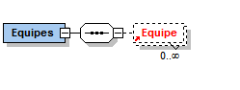

A team is composed of fencers.
The original XML document mentioned that the team ID will be the nation name, but this raises issues with 2 teams of the same countries, with country spelling, etc.
In this document, a team will have a name and a country, and the ID will be a unique identifier to the competition. For upward compatibility, we keep it as a string.
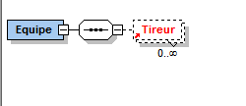
Attributes of a team
A Equipe has exactly the same attributes as a Tireur with the following remarks:
- A team has no Prenom, no Lateralite
- Nom is a new attribute to remove the ambiguity between Team identifier and nation, in case of 2 teams of the same nation, or in case of spelling issues, etc.
- Nation holds the nation code and not the nation name (new feature)
Name | Type | Mandatory | Comment
Classement | Xs:integer |  | In the input files: official FIE or national ranking before the competition. In the output files: final ranking in the competition. Must be omitted if the team has no ranking. (FIE document 2012)
Club | Xs:string |  | Team’s club (optional).
ID | Xs:string | x | Unique identifier in the competition. In FIE files this comes from the database identifier. Mandatory inside lists of fencers. Inside matches or poules, only REF is used.
Ligue | Xs:string |  | Team’s league (optional)
Nation | Xs:string | x | Team’s nation code according to CIO codes. This is mandatory for FIE competitions. Required for the Scoreboards and the Scouting.
Nom | Xs:string | x | Name of the team.
Points | Xs:string |  | Points contains the number of points of the team in relation to its ranking. The decimal separator is a dot (.)
REF | Xs:string |  | Reference to the ID of a team inside a Match, a Poule, a TourDePoules or any other entity
RangFinal | Xs:integer |  | Used inside stages. Omitted if no final ranking in a stage. Mandatory when the information is known
RangInitial | Xs:integer |  | Used inside stages and in the competition.  Can be used to store FIE ranking before the competition in output files at the competition fencers list level.
Statut | Xs:string |  | Status of the team. Various meanings according to the context. Required for the Scoreboards, should be mandatory when the information is known.

In particular, a team may have an initial ranking (Classement) and a number of points, same as fencers. It also has an Id. Exceptional status for teams are the same as for fencers (DNS, DNF, EXC, MED).
The rules to compute a team status are the following:
T1) A team will be marked as DNS if it has less than 3 fencers at the start of the competition.
T2) A team will be marked as MED if it has only 2 valid fencers (1 injured out of 3, 2 out of 4)
T3) A team will be excluded if it has any excluded member, either fencer, coach or captain
T4) In case of injury, the fencer will be replaced if possible. In this case, the assaut in the XML file will keep the original fencer name with status of MED (resp. DNF).
For instance, injury in the 3rd Assaut
<Assaut ID=” 3 “ <Tireur ID=” 4 “> Statut = “ MED “ ….>
In this replacement case, the status of the team will be still normal.
Note: the size of a team is unbounded. A team is a sequence of fencers, which may be repeated if they fence twice, for instance in Marseille 2017 formula with gender Italian relays with mixed weapon: men epee, men foil, men sabre, men sabre, men foil, men epee.

Match
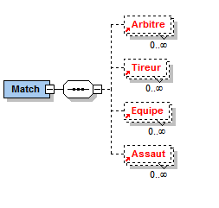
A match may represent an individual or a team match or an Italian relay. Its ID it its sequence number in the Poule or the Tableau to which it belongs.
A match holds a list of any number of referees or none, a list of any number of Assaut or none, a list of any number of Equipe or none. Of course, a match holds either Tireurs or Equipes but not both, whether it is an individual or a team match.
Note: It would have been better to introduce a new element MatchEnEquipe, but for upward compatibility this is not chosen. This allows to be able to keep the short form for team matches with only the sum of scores of all fencers without detailing each Assaut.
The number of competitors in a match is unbounded to account for mixed italian relays with teams of 6.
The number of Assaut (rounds) is also unbounded.
Match attributes
Name | Type | Mandatory | Comment
Date | Xs:string |  | Date of the match in the format  (DD.MM.YYYY). Required for the Scoreboards, should be mandatory when the information is known.
Heure | Xs:string |  | Schedule of the match in the format HH:MM (e.g. 09:00). Required for the Scoreboards, should be mandatory when the information is known.
ID | Xs:string | x | Sequence number in the Poule or the Tableau to which it belongs.
Piste | Xs:string |  | Piste number or any symbol for instance ROUGE, BLEUE, VERTE, JAUNE, PODIUM. Required for the Scoreboards, should be mandatory when the information is known.
Statut | Xs:string |  | Current status of the match among  - P (Programme): Scheduled  - R (Prêt): Ready to go  - L (Live): Live  - F (Officieux, Fini): Completed but not validated  - O (Officiel): Completed and validated  This attribute may be omitted, and is used for partial results

Important note: the 2012 FIE document mentioned p 14 and 16 that a bye match would have no ID and would shift other matches Ids. Instead we suggest to keep the ID as all other matches.
It is possible to attach the role of a referee in the Arbitre element:
<Arbitre REF="ArbitreID_n" Role = "r"/>, with potential values of role: P (principal), V (video), A (assistant).
Expected attributes of Tireur element inside a Match or an Assaut in team competitions:

Name | Type | Mandatory | Comment
CartonJaune | Xs:integer |  | Optional. Number of yellow cards received by the fencer in the match or the assaut (0,1)
CartonRouge | Xs:integer |  | Optional. Number of red cards received by the fencer in the match or the assaut (0,1,...n)
DemandeVideoRejetee | Xs:integer |  | Optional. Number of unsuccessful video requests (0,1,2) in the match
REF | Xs:string | x | References the Tireur with ID of the same value
Score | Xs:integer | x | Number of hits. Omitted if the match has not been fought or has not begun. There is a distinction between a match without score (omitted attribute) because it has not yet started and a match with a null score Score=”0”
Statut | Xs:string | x | Fencer status at the end of the match (DNS, DNF, MED, EXC, V = Victory  D = Defeat)

Note: It would have been more accurate to introduce an element MatchTireur, but for upward compatibility we will keep this ambiguity.

Examples
<Match ID="15" Piste="BLEUE">
<Arbitre REF="13"></Arbitre>
<Tireur REF="17" Score="1" Statut="D"></Tireur>
<Tireur REF="116" Score="2" Statut="V"></Tireur>
</Match>
<-!2 referees: one principal, one video->
<Match ID="1">
<Arbitre REF="2" Role="P" ></Arbitre>
<Arbitre REF="1" Role="V" ></Arbitre>
<Tireur REF="1" Score="4" Statut="D"></Tireur>
<Tireur REF="2" Score="15" Statut="V"></Tireur>
</Match>
Note: The element Tireur is used both for match competitor and for individual competition participant. This ambiguity is kept for upward compatibility but a better option would be to use Competitor inside a Match.
A Tireur reference may point either to a Participant (Tireur element) or a team (Equipe element).
<-! Yellow Card->
<Match ID="1">
<Tireur REF="1" Score="4" Statut="D" CartonJaune="1" ></Tireur>
<Tireur REF="2" Score="15" Statut="V"></Tireur>
</Match>

Exceptional cases (DNS, DNF, EXC, MED)
For exceptional cases within a match, the Tireur status in the match will be marked with the acronym (DNS, DNF, MED or EXC), and the opponent as “V” for Victory. This holds also for teams (Equipe).
See Annex for meaning of the statuses.
Match with medical reason
<Match ID="1">
<Tireur Score="5" REF ="31" Statut="MED"></Tireur>
<Tireur Score="15" REF ="3" Statut="V"></Tireur>
</Match>

Match with exclusion
<Match ID="1">
<Tireur REF ="45" Statut="EXC"></Tireur>
<Tireur REF ="34" Statut="V"></Tireur>
</Match>
Match with DNF
A no show or a non-medical issue will be noted as DNF (Did not finish).
<Match ID="1">
<Tireur REF ="45" Statut="DNF"></Tireur>
<Tireur REF ="34" Statut="V"></Tireur>
</Match>
Byes
In case a tableau match is not fought (bye) one of the fencers will be left blank, and the score and the status of the fencers will not be mentioned:
<Match ID="1">
<Tireur ID="45”/>
<Tireur/>
</Match>
Note: this is a small modification with the 2012 document that mentions that in this case one of the Tireur XML element is skipped like in the following:
<Match ID="1">
<Tireur ID="45”/>
</Match>
Keeping both elements allows to know how to display the tableau because the bye might be in the first element or the second element.
Match scheduling
For competition display, it is sometimes useful to draw a match in a tableau without knowing yet the fencers’names.
<Match ID="1" Piste=”PODIUM” Heure=”09:00”>
<Tireur/>
<Tireur/>
</Match>

Assaut
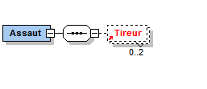
An Assaut is a round inside a team match or an Italian relay.
An Assaut has only 0 or 2 fencers.
Attributes of an Assaut :

Name | Type | Mandatory | Comment
ID | Xs:string | X | Sequence number of an Assaut inside a Match
Statut | Xs:string |  | Current status of the assaut among  - P (Programme): Scheduled  - R (Prêt): Ready to go  - L (Live): Live  - F (Officieux, Fini): Completed but not validated  - O (Officiel): Completed and validated  This attribute may be omitted, and is used for partial results

Example of a team match with assauts:
<Match ID="1">
<Equipe REF="1" Score="44" Statut="D"/>
<Equipe REF="2" Score="45" Statut="V"/>
<Assaut ID="1">
<Tireur REF="76" Score="2" />
<Tireur REF="31" Score="5" />
</Assaut>
<Assaut ID="2">
<Tireur REF="68" Score="8" />
<Tireur REF="14" Score="2" />
</Assaut>
… up to 9 Assauts.
Example of a red card in an Assaut:
<-! Red Card->
<Assaut ID="1">
<Tireur REF="3" Score="4" Statut="D" CartonRouge="1" ></Tireur>
<Tireur REF="2" Score="15" Statut="V"></Tireur>
</Assaut>
Example of replacement of an injured fencer (MED) in a team match
<Match ID="1">
<Equipe REF="1" Score="44" Statut="D"/>
<Equipe REF="2" Score="45" Statut="V"/>
<Assaut ID="1">
<Tireur REF="76" Score="2" Statut="MED"/>
<Tireur REF="31" Score="5" />
</Assaut>
….

Italian relay matches with several weapons
Italian relays with several weapons are not in the statutes of the FIE. Nonetheless, the standard could handle that case easily. The Arme attribute of the competition will be marked as “M” for Mixed, and each fencer will have a weapon attribute. Rounds in a match will only contain fencers of the same weapon.
This implies that a single fencer may not change weapon during a match, and that different weapons inside a match will involve different fencers.

Phases
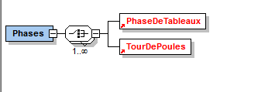
There are 2 types of phases: PhaseDeTableaux composed of SuiteDeTableaux composed of Tableaux, and TourDePoules composed of Poules.
The Phases element is a sequence of a choice between PhaseDeTableaux and TourDePoules. It is potentially possible with this schema to have any number of PhaseDeTableaux and TourDePoules in any sequence.

TourDePoules
A TourDePoules is a stage composed of Poules.
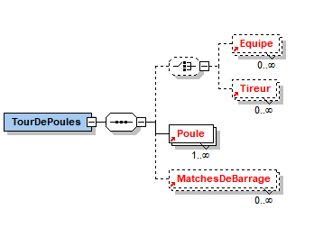
A TourDePoules is composed of Poules, as well as references to competitors (either Equipes or Tireurs).
A TourDePoules first lists either Equipes or Tireurs, then lists a number of Poules.
A TourDePoules holds only fencers enrolled in the TourDePoules, including exempted fencers at the beginning of the TourDePoules.
Fencers without ranking will have no RangFinal attribute.
MatchesDeBarrage may be used in senior competitions, be it the case.
For each Tireur, the following attributes are expected:

Name | Type | Mandatory | Comment
REF | Xs:string | x | ID’s of the referenced fencer in the competition Tireurs section
RangInitial | Xs:integer | x | Initial fencer’s ranking in the Tour de poules
RangFinal | Xs:integer |  | Final fencer’s ranking in the Tour De Poules. Omitted if not ranked. Required for the Scoreboards, should be mandatory when the information is known.
Statut | Xs:string |  | Fencer’s status at the end of the Tour De Poules (X = exempted, Q = qualified,  N = not qualified, DNF = Did not finish, EXC = exclusion, DNS = Did not start, MED = medical). Required for the Scoreboards, should be mandatory when the information is known.
FIE does not use team TourDePoules, but in the case of team TourDePoules would be used, the same attributes would be expected from an Equipe inside a TourDePoules, only the REF will reference a team ID instead of a fencer ID.
In case the status is not known or is normal, the attribute is omitted (no default value).
Note: an alternative would be to introduce instead of Tireur a Concurrent element that would reference either a Tireur or an Equipe, but this has not been chosen for upward compatibility issues.
Attributes of a TourDePoule
Name | Type | Mandatory | Comment
ID | Xs:string | x | The stage sequence number, e.g. 1 if the TourDePoules comes first.
NbDePoules | Xs:integer | x | Number of poules
NbExemptes | Xs:integer |  | Number of fencers exempted from the Tour de Poules (default is 0)
NbQualifiesParPoule | Xs:integer | x | Number of fencers qualified by ranking in each poule, 0 by default
NbQualifiesParIndice | Xs:integer | x | Number of fencers qualified by index in the whole Tour de Poules, 0 by default.  - This number should be updated in case of ties yielding to increased number of qualified fencers.  - This number should not count the number of fencers exempted from the Tour de Poules.
PhaseId | Xs:string |  | The PhaseID attribute is a unique identifier of phases inside the competition and allows to chain stages in sequence. Required for the Scoreboards and the Scouting.
PhaseSuivanteDesQualifies | Xs:string |  | PhaseId that references the next stage for qualified competitors. If this attribute is missing, this is the last stage of the competition.
PhaseSuivanteDesElimines | Xs:string |  | PhaseId that references the next phase for eliminated competitors. If this attribute is missing the eliminated fencers will have no repechage and their final ranking will be the one obtained at the end of this stage. Required for the Scoreboards, should be mandatory when the information is known.
Example:
<TourDePoules ID="1" NbDePoules="11" NbQualifiesParIndice="0" NbQualifiesParPoule="0" PhaseID="Phase 1 - Poules">
<Tireur REF=”47” RangFinal="47" RangInitial="1" Statut="Q"></Tireur>
<Tireur REF=”54” RangFinal="37" RangInitial="2" Statut="Q"></Tireur>
…
<Poule ID="1"> …
<Poule ID=”2”>…

Poule
The poule element is composed of a list of fencers (Tireurs) participating in the poule with their seeding in the poule, a list of referees which can be empty and a list of match results which can be empty.
Note: it is useful to allow for empty results to be able to use this format for partial results.
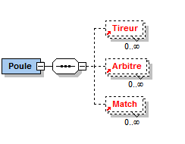
Attributes of Poule
Name | Type | Mandatory | Comment
Date | Xs:string |  | Date of the beginning of the poule in format  (DD.MM.YYYY). Required for the Scoreboards, should be mandatory when the information is known.
Heure | Xs:string |  | Time schedule of the poule in format: HH:MM (e.g. 09:00). Required for the Scoreboards, should be mandatory when the information is known.
ID | Xs:string | x | The ID attribute is a unique identifier of a poule in a Tour de poules. Usually the poule number
Piste | Xs:string |  | Piste used by the poule. Required for the Scoreboards, should be mandatory when the information is known.
Statut | Xs:string |  | Current status of the poule among  - P (Programmé): Scheduled  - R (Prêt): Ready to go  - L (Live): Live  - F (Officieux, Fini): Completed but not validated  - O (Officiel): Completed and validated  This attribute may be omitted, and is used for partial results
Note: It may happen that some poules are split among 2 pistes. Each match may indicate its own piste.
Expected attributes of Tireur (resp. Equipe) inside a Poule:

Name | Type | Mandatory | Comment
NoDansLaPoule | Xs:integer |  | Fencer’s seeding in the poule
NbVictoires | Xs:integer |  | Fencer’s number of victories. Required for the Scoreboards, should be mandatory when the information is known.
NbMatches | Xs:integer |  | Fencer’s number of matches fought. Required for the Scoreboards, should be mandatory when the information is known.
RangPoule | Xs:integer |  | Fencer’s ranking in the poule. Required for the Scoreboards, should be mandatory when the information is known.
TD | Xs:integer |  | Number of given hits. Required for the Scoreboards, should be mandatory when the information is known.
TR | Xs:integer |  | Number of received hits. Required for the Scoreboards, should be mandatory when the information is known.

All attributes are required for the Scoreboards, should be mandatory when the information is known.
Each match inside a Poule is composed of the 2 fencers (Tireur), resp. Equipe participating in it. The ID is a unique identifier of the match inside a Poule, usually its sequence number.

<Poule ID="1" Piste="BLUE">
<Tireur NbMatches="6" NbVictoires="2" NoDansLaPoule="1" RangPoule="6" REF="67" TD="15" TR="28"/>
<Tireur NbMatches="6" NbVictoires="0" NoDansLaPoule="2" RangPoule="7" REF="167" TD="15" TR="30"/>
<Tireur NbMatches="6" NbVictoires="4" NoDansLaPoule="3" RangPoule="3" REF="17" TD="22" TR="15"/>
<Tireur NbMatches="6" NbVictoires="3" NoDansLaPoule="4" RangPoule="4" REF="117" TD="23" TR="17"/>
<Tireur NbMatches="6" NbVictoires="5" NoDansLaPoule="5" RangPoule="1" REF="116" TD="23" TR="18"/>
<Tireur NbMatches="6" NbVictoires="3" NoDansLaPoule="6" RangPoule="5" REF="166" TD="23" TR="24"/>
<Tireur NbMatches="6" NbVictoires="4" NoDansLaPoule="7" RangPoule="2" REF="66" TD="23" TR="12"/>
<Arbitre REF="13"/>
<Match ID="1" Piste="BLUE">
<Arbitre REF="13"/>
<Tireur REF="67" Score="1" Statut="D"/>
<Tireur REF="117" Score="5" Statut="V"/>
</Match>
<Match ID="2" Piste="BLUE">
<Arbitre REF="13"/>
<Tireur REF="167" Score="4" Statut="D"/>
<Tireur REF="116" Score="5" Statut="V"/>
</Match>

PhaseDeTableaux
A PhaseDeTableaux holds tableaux sequenced in SuiteDeTableaux.
The PhaseDeTableaux holds only the list of fencers (resp. teams) qualified for the PhaseDeTableaux together with their initial ranking and final ranking in the PhasedeTableaux.
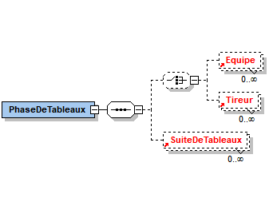
Attributes of a PhaseDeTableaux
Same as TourDePoules without number of qualified.
Name | Type | Mandatory | Comment
ID | Xs:string | x | The stage sequence number, e.g. 1 if the TourDePoules comes first.
NbExemptes | Xs:integer |  | Number of fencers exempted from the Phase de Tableaux (default is 0)
PhaseId | Xs:string | x | The PhaseID attribute is a unique identifier of phases inside the competition and allows to chain stages in sequence. Required for the Scoreboards and the Scouting.
PhaseSuivanteDesQualifies | Xs:string |  | PhaseId that references the next stage for qualified competitors. If this attribute is missing, this is the last stage of the competition.
PhaseSuivanteDesElimines | Xs:string |  | PhaseId that references the next phase for eliminated competitors. If this attribute is missing the eliminated fencers will have no repechage and their final ranking will be the one obtained at the end of this stage. Required for the Scoreboards, should be mandatory when the information is known.

SuiteDeTableaux
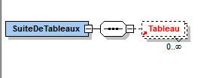
A SuiteDeTableaux is an unbounded collection of Tableau. It may be empty.
Quoting J.F. Nicaud
A SuiteDeTableaux is composed of N tableaux such as winners of matches 1 and 2 of the K tableau meet in the match 1 of the K+1 tableau.
It can be used for fenced places or derived competitions.
For instance, a PhaseDeTableaux of 8 competitors with all fenced places will have:
- One main suite
- A suite for 3rd place with only one tableau of one match
- A suite for 5th place with 2 tableaux
- A suite for 7th place with one tableau
- 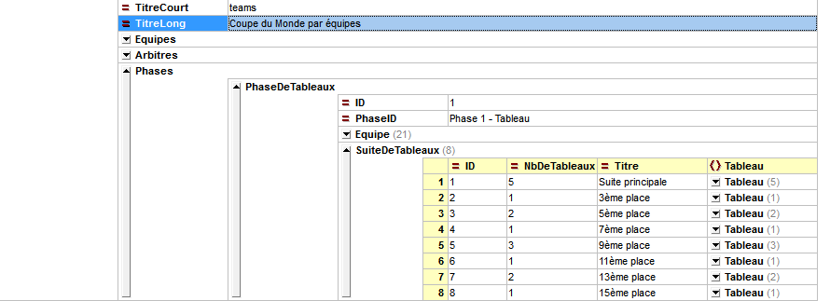
Each suite has a letter. For team world cup competition, the suites will have a letter corresponding to the place in the alphabet of the fenced place (for instance C for the 3rd place, E for the 5th place, G for the 7th, I for the 9th, etc.). If letters are not enough, double letters will be used (AA, AB, etc.). The tableaux in the suite will have IDs composed of the suite letter and the tableau size if it was complete, for instance E4 for the first tableau in the 5th place.

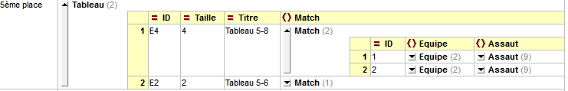

The chaining will take into account the eliminated destination (DestinationDesElimines):
Main suite
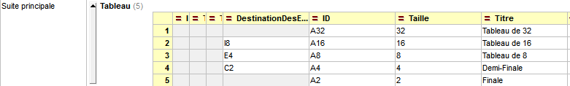
5th place

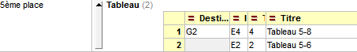
9th place
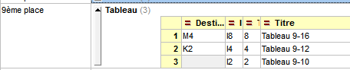
13th place
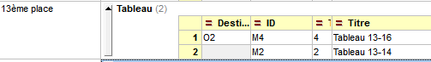

Attributes of SuiteDeTableaux
Name | Type | Mandatory | Comment
ID | Xs:string | x | The ID attribute is a unique identifier for the SuiteDeTableaux inside a PhaseDeTableaux. It will be used to chain SuiteDeTableaux inside the PhaseDeTableaux when loosers of some level go to a branch.
NbDeTableaux | Xs:integer | x | Number of Tableaux inside the SuiteDeTableaux
Lettre | Xs:string | x | Acronym (one or 2 letters) to prefix Tableaux id’s; usually A for the main SuiteDeTableaux
Titre | Xs:string |  | Description of the SuiteDeTableaux
DestinationDesQualifies | Xs:string |  | Reference on the ID of the SuiteDeTableaux destination of the qualified fencers. If this attribute is missing, the qualified fencers will participate in the phase referenced by PhaseSuivanteDesQualifies of the ancestor PhaseDeTableaux.
This document adds a new attribute, Lettre, which defines the letters used to prefix the Tableaux ids.

Tableau
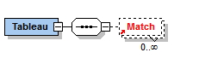
Quoting the original document:
“Tableau : C’est un terme d’escrime qui a tantôt le sens strict de tableau dans lequel chaque tireur tire un seul match, tantôt le sens plus général de suite de tableaux. Dans ce document, nous utilisons le sens strict. »
A Tableau is a collection of matches. A tableau is identified according to the suite where it belongs.
Attributes of a tableau
Name | Type | Mandatory | Comment
ID | Xs:string | x | The ID attribute is a unique identifier of a tableau inside a SuiteDeTableaux  Usually the ID is the suite letter followed by the tableau size, e.g. A32, B4 …Remark : The Cyrano protocol requires Ids to start with letters for tableaux, and numbers for poules
Statut | Xs:string |  | Current status of the tableau among  - P (Programme): Scheduled  - R (Prêt): Ready to go  - L (Live): Live  - F (Officieux, Fini): Completed but not validated  - O (Officiel): Completed and validated  This attribute may be omitted, and is used for partial results
Taille | Xs:integer | x | Size of the Tableau if it would be complete (128, 64, 32 ….). Required for the Scoreboards, should be mandatory when the information is known.
Titre | Xs:string | x | Description of the tableau. Required for the Scoreboards, should be mandatory when the information is known.
DestinationDesElimines | Xs:string |  | This attribute references the Tableau id destination of the eliminated. If this attribute is missing, this means that the defeated will be ranked according to their initial seeding. Remember that the destination for winners has not to be specified, it is just the next Tableau in the SuiteDeTableaux. Required for the Scoreboards, should be mandatory when the information is known.

Matches de barrage
For senior competition, some matches de barrage may be used. Usually there is only one, but exceptional cases of several matches de barrage may happen (case of Nantes some years ago).
An optional element MatchesDeBarrage is added to the TourDePoules and contains one or several elements Match.
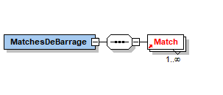

Senior competitions
Senior competitions are characterized by a preliminary Tableau and a final Tableau, or more precisely 3 stages: one TourDePoules, and 2 PhaseDeTableaux.
In the competition body, we list all present fencers with the FIE ranking (RangInitial), and final ranking (Classement), optionally a status of exceptional case, following the general rule.
We have a list of 16 exempted before the poules (list X1).
In the tour de poules XML block, we will exclude the list X1. We list only fencers participating in the poules, with a status of X (exempted) for the first 16 (list X2) at the end of the stage, Q for the qualified (list Q1), N for the non-qualified, or any other status for exceptional cases. All have initial ranking starting from 1 in the seeding order, and final ranking from the tour de poules if they are ranked.
In the intermediate Phase de tableaux, we list fencers in list Q1 with initial ranking starting from 1 in the sequence of the tour de poule ranking, with 32 reaching status Q (list Q2), the others as N. Final ranking is from intermediate tableau ranking.
In the final Phase de Tableaux we list fencers of list X1 with initial rankings 1 to 16 before the pair drawing, list X2 with initial rankings 17 to 32, list Q2 with initial rankings > 32 and all with final ranking from final tableau ranking.
Important note: initial ranking in final Tableau is the one preceding the pair drawing.
Each PhaseDeTableaux has only one SuiteDeTableaux with letter A, and thus all tableaux will be prefixed by A.

Senior competitions may also register some matches de barrage (see above).

Arbitres
An Arbitre represents a referee.
The Arbitres element is an unbounded collection of Arbitre which may be empty.
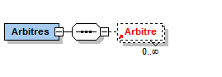
Referees are listed at the competition level. They are referenced at the poule level, the match level. They are not listed at the Tableau level, nor at the Assaut level.

Attributes of an Arbitre
Name | Type | Mandatory | Comment
Categorie | Xs:string |  | Referee’s category. For FIE competitions, codes A, B and C are allowed.
CategorieEpee | Xs:string |  | Referee’s epee category independent of the competition weapon
CategorieFleuret | Xs:string |  | Referee’s foil category independent of the competition weapon
CategorieSabre | Xs:string |  | Referee’s sabre category independent of the competition weapon
Club | Xs:string |  | Referee’s club (optional)
DateNaissance | Xs:string |  | Birth date of the referee in the format (DD.MM.YYYY).
ID | Xs:string | x | ID is a unique identifier among all the referees in the competition. It can be freely chosen by organizers even if it is adb-visable to use the license number.  It is used to reference the referee inside poules or matches.
IDTournoi | Xs:string |  | Unique ID of referee in tournament accreditation system
Licence | Xs:string |  | Referee license number according to the competition calendar (FIE or national). This number is provided in the input files.
Ligue | Xs:string |  | Referee’s league (optional)
Nation | Xs:string |  | Referee’s nation code as listed by CIO. This is mandatory for international competitions. Required for the Scoreboards, should be mandatory when the information is known.
Nom | Xs:string |  | Referee’s name. Required for the Scoreboards, should be mandatory when the information is known.
Prenom | Xs:string |  | Referee’s first name. Required for the Scoreboards, should be mandatory when the information is known.
REF | Xs:string |  | Used for references to referees
Role | Xs:string |  | Role of the referee referred by a poule or a match. If the attribute is omitted, the principal role is assumed.  3 possible values :  - P for main referee (principal)  - A for assistant  - V for video  Required for the Scoreboards, should be mandatory when the information is known.
Sexe | Xs:string |  | Gender code of the referee (M = Masculine et F = Feminine). Required for the Scoreboards, should be mandatory when the information is known.

Officials
Officials are included in the accreditation system and are important parts in most fencing competitions. Officials can have different roles in a fencing competition: Directoire Technique, Referees Delegate, FIE Supervisor...
Officiels is an optional element in a competition composed of Officiel elements.
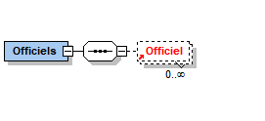
An Officiel element has the following attributes :
Name | Type | Mandatory | Comment
Nom | Xs:string |  | Family name
Prenom | Xs:string |  | First name
IDTournoi | Xs:string |  | Unique ID for official in tournament accreditation system
Nation | Xs:string |  | NOC code of the official’s nation
Role | Xs:string |  | Valid values: DT (Directoire Technique), DA(Referee Delegate), S(Supervisor)
Sexe | Xs:string |  | Gender code of the official (M = Masculine et F = Feminine).

Pistes
Pistes are not listed at the competition level. They are mentioned at the Poule level, the match level.
Pistes are identified either by their number or by any symbol such as ROUGE, VERTE, BLEUE, JAUNE, PODIUM …

Enumerated values

Status of Tireur
Inside a match a Tireur may have the following one letter status:
- DNS for Did Not Start
- EXC for Exclusion
- DNF for Did Not Finish
- MED for Medical case
- V for victory
- D for defeat
In a TourDePoules a Tireur may have the status:
- Q for Qualified
- X for exempted at the end of the TourDePoules
- N for non qualified
- DNS for Did Not Start
- EXC for Exclusion
- DNF for Did Not Finish
- MED for Medical case

Weapons
Weapons (Arme attribute) may have the following values:
- E for Epee
- F for foil
- S for sabre
- X for mixed

Competition categories
Competition categories values are not a closed list, because they might reflect national categories not listed here. FIE competition categories may have the following values:
- V for veteran
- S for senior
- J for junior
- C for cadet (C with ascii code 67 and not C with Unicode U+0421)

Some fencing softwares might implement additional categories such as:
- U23
- U20 (equivalent to Junior)
- U17 (equivalent to Cadet)
- U14
- U11
- U10
- M15, M13, M11 …
- A for any
- Etc.

Gender
A competition gender may be
- F for feminine
- M for masculine
- X for mixed (no constraint)

Competition domain
A competition domain may be (same as original document):
- I for international
- N for national
- R for regional
- L for league
- C for club
- Z for zonal

Team competition type
- S for standard
- V for veteran
- I for italian relay

Status of a poule or a match or an assaut
- P (Programme): Scheduled
- R (Prêt): Ready to go
- L (Live): Live
- F (Officieux, Fini): Completed but not validated
- O (Officiel): Completed and validated

Role of an official
- DT: Directoire Technique
- DA: Referee Delegate
- S: Supervisor

Role of a referee
- P for main referee (principal)
- A for assistant
- V for video

Handisport competition class (Classe)
- A
- B
- C
- Open

Cote
- D for right
- G for left

Lefthandedness
- D for right
- G for left

